**Experiment - 4**

**Aim:**

**WAP for using Input, Output and fail predicates in prolog.**

**Procedure:-**

**Write program using write, writef, readint, readchar, readln, readreal predicates.**

1. Store facts of employee name, age, job location, marital status and gender.

Display-

(i) list of married & unmarried employees

(ii) List of male & female employees

(iii) List of employees for given job location

Prolog Code:

domains

name,mrst,loc,gen,age=symbol

predicates

start

rule(integer)

status(name,mrst)

location(name,loc)

gender(name,gen)

clauses

status(devanshi,unmarried).

status(aanandi,unmarried).

status(bhargav,married).

status(aash,married).

gender(devanshi,female).

gender(aanandi,female).

gender(aash,male).

gender(bhargav,male).

location(devanshi,gandhinagar).

location(aanandi,rajkot).

location(aash,junagadh).

location(bhargav,jamnagar).

start:-

write("***********OPTIONS***********"),nl,

write("1.list of married employees"),nl,

write("2.list of unmarried employees"),nl,

write("3.list of male employees"),nl,

write("4.list of female employee"),nl,

write("5.list of employee at given location"),nl,

write("Enter your choice : "),

readint(C),rule(C).

rule(1):-status(Z,married),write(Z),nl,fail.

rule(2):-status(Z,unmarried),write(Z),nl,fail.

rule(3):-gender(Z,male),write(Z),nl,fail.

rule(4):-gender(Z,female),write(Z),nl,fail.

rule(5):-write("Enter Location : "),readln(L),location(Z,L),write(Z),nl,fail.

Output Screenshots:

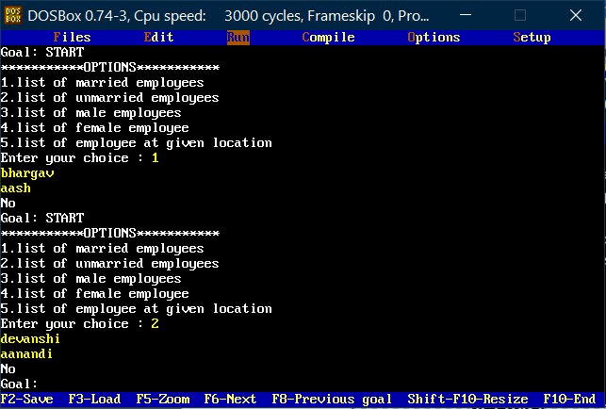

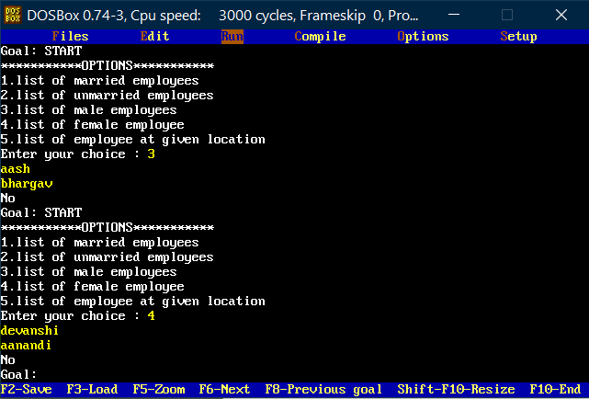

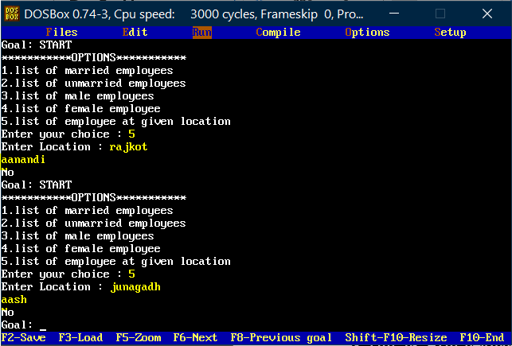

1. Create a small set of facts and rules on who is the ancestor of whom.

Display-

i) who is ancestor of given person.

ii) Complete list i.e. who is ancestor of whom.

Prolog Code:

domains

name=symbol

predicates

start

rule(integer)

ancestor(name,name)

clauses

ancestor(devanshi,dineshbhai).

ancestor(aanandi,ramnikbhai).

ancestor(aash,ramnikbhai).

ancestor(bhargav,dineshbhai).

ancestor(mishri,bhargavbhai).

ancestor(riya,manishbhai).

start:-

write("**************OPTION**************"),nl,

write("6.who is ancestor of given person?"),nl,

write("7.List of 'who is ancestor of whom?'."),nl,

write("Enter your choice : "),nl,

readint(C),rule(C).

rule(6):-

write("Enter the name : "),

readln(N),ancestor(N,X),write(X),nl,fail.

rule(7):-

nl,write("Complete list of : 'who is ancestor of whom'"),nl,nl,

write("***person-ancestor***"),nl,!,ancestor(X,Y),write(X),write(" - ",Y),nl,fail,nl.

Output Screenshots:

